Project Management Case
You are working for a large, apparel design and manufacturing company, Trillo Apparel Company (TAC), headquartered in Albuquerque, New Mexico. TAC employs around 3000 people and has remained profitable through tough economic times. The operations are divided into 4 districts; District 1 – North, District 2 – South, District 3 – West and District 4 – East. The company sets strategic goals at the beginning of each year and operates with priorities to reach those goals.

Trillo Apparel Company Current Year Priorities
- Increase Sales and Distribution in the East
- Improve Product Quality
- Improve Production in District 4
- Increase Brand Recognition
- Increase Revenues

Company Details
Company Name: Trillo Apparel Company (TAC)
Company Type: Apparel design and production
Company Size: 3000 employees
Position | # Employees
Owner/CEO | 1
Vice President | 4
Chief Operating Officer | 1
Chief Financial Officer | 1
Chief Information Officer | 1
IT Department | 38
District Manager | 4
Sales Team | 30
Accountant | 12
Administrative Assistant | 7
Order Fullfilment | 45
Customer Service | 57
Designer | 24
Project Manager | 10
Maintenance | 25
Operations | 2500
Shipping Department | 240
Total Employees | 3000

Products: Various Apparel
Corporate Location: Albuquerque, New Mexico

TAC Organization Chart
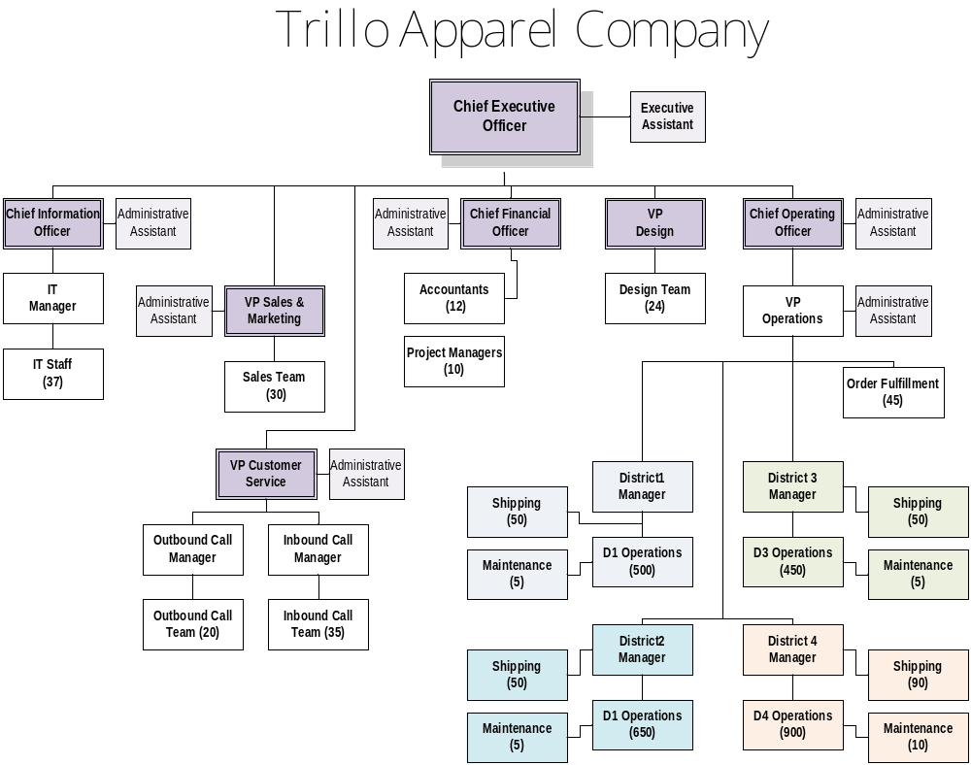

District 4 Production Warehouse Move Project Details
The business has expanded considerably over the past few years and District 4 in the East has outgrown its current production facility. Because of this growth the executives want to expand the current facility, moving the whole facility 10 miles away. The location selected has enough room for the production and the shipping department. However, the current warehouse needs some renovation to accommodate the district’s operational needs.
The VP of Operations estimates the production and shipping warehouse move for District 4 will provide room required to generate the additional $1 million/year product revenues to meet the current demand due to the expanded production capacity. Daily production generates $50,000 revenue so a week of downtime will cost $250,000 in lost revenues.
The move must be completed in 4 months.
Mileage between the old and new facilities is 10 miles.
Bids have been received from contractors to build out the new office space and production floor and have signed contracts for work as follows:
Activity | Company Providing Services | Total Contract | Supplies | Time Needed
Pack, move and unpack production equipment | City Equipment Movers | $150,000 | n/a | 5 Days
Move non-production equipment and materials | Express Moving Company | $125,000 | n/a | 5 Days
Framing | East Side Framing & Drywall | $121,000 | $125,000 | 15 Days
Electrical | Sparks Electrical | $18,000 | $12,000 | 10 Days
Plumbing | Waterworks Plumbing | $15,000 | $13,000 | 10 Days
Drywall | East Side Framing & Drywall | $121,000 | $18,000 | 15 Days
Finish Work | Woodcraft Carpentry | $115,000 | $15,000 | 15 Days
Build work benches for production floor | Student Workers Carpentry | $112,000 | $110,000 | 15 Days

Production workdays are Monday through Saturday. The actual move must be completed in 5 days for as little disruption to production activities as possible. All contractors are on other projects but have been booked in advance. The contractors will gain the necessary permits and schedule city and county inspections but these tasks need to be identified separately due to the length of time it can take. Permitting and inspections can take from one to three weeks, depending upon schedule and the flexibility of the inspector. The new warehouse is empty and can be accessed immediately. Framing cannot start until the permits are received. Electrical and plumbing can begin as soon as the framing is finished. Drywall cannot start until the electrical and plumbing inspections are complete. After the drywall is completed, final inspections will be completed by the county and city. After both the county and city have passed the new construction, finish work can begin. Building the product floor work benches can occur at any time before the move occurs.

