Assessment item 2
Assignment 1
Value: 10%
Due date: 07-Sep-2016
Submission method options
Alternative submission method
Task
There are Eight tasks to complete in this assignment. There are 30 marks in total.
Using Packet tracer implement the following tasks based on the network topology of a small business given below. Smart Sale Pty Ltd has four departments: Sales, Production, Marketing and Management. Its Central office (HQ) controls the connection between Internet Service Provider (ISP) and one local office (R1). Examine the network requirements and complete the eight questions to make the company network service running.
You must submit your answer file in word or pdf and packet tracer file to EASTS by the due date.
Please use your last 4 digits of your student ID as the first two octets of your network address. Keep other bits same as what are shown in the addressing table and the figure below. For example,if your student ID is 11555787, using the last 4 digits (5787). your main network address will be 57.87.0.0.

Consider the following Topology in the figure below:
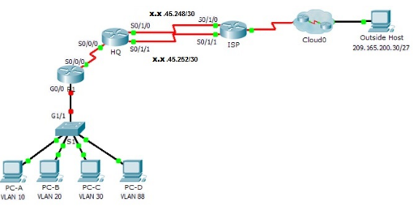

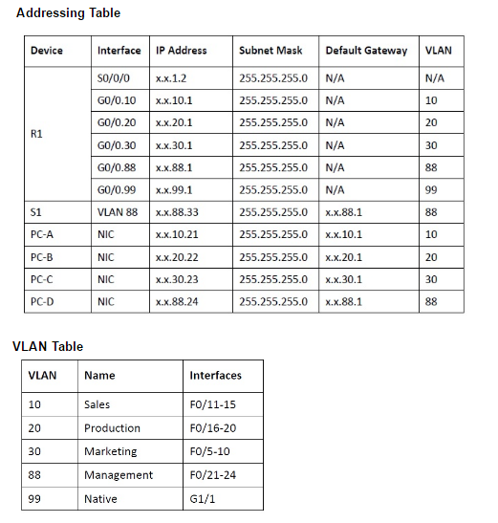

You need to use Packet Tracer to implement the given topology and to complete the following tasks:
1. Configure four VLANs as required on S1 and enable Trunking on S1. (4 marks)
2. Configure inter-VLAN routing on R1 based on the Addressing Table. (4 marks)
3. Configure four directly attached static routes on HQ to four VLANs: 10, 20, 30 and 88. (4 marks)
4. Configure directly attached static routes on HQ to reach Outside Host. (4 marks)
a. Configure the primary path through the Serial 0/1/0 interface.
b. Configure the backup route through the Serial 0/1/1 interface with a 10 AD.
5. Configure directly attached primary and backup summary routes on ISP for the entire x.x.0.0/17 address space. (4 marks)
a. Configure the primary path through the Serial 0/1/1 interface.
b. Configure the backup route through the Serial 0/1/0 interface with 25 AD.
6. Configure a directly attached default route on R1. (2 marks)
7. Verify connectivity by making sure all the PCs can ping Outside Host (2 marks)
8. Explain and analysis the routing process of three routers in the case of ping from PC-A to Outside Host. (6 marks)
Rationale
In this assessment item, tasks are designed to reinforce the application of configuring routers for inter-VLAN communication and configure static routes to reach destinations outside of your network. Your ability demonstrate your skills at configuring inter-VLAN routing, static and default routes are also included.
The tasks in this assignment relate to Learning Outcome 3 & 4:
- be able to configure and troubleshoot networks to improve efficiency and security;
- be able to configure, verify and solve a variety of problems involving Virtual Local Area Networks;
Marking criteria
The following criteria are designed to guide you in your presentation and preparation of your assignment. The criteria apply generally across all questions to show you the standard required for each of the criteria.
Criteria | HD | DI | CR | PS | FL
Accuracy | All procedures articulated and applied clearly and concisely, all calculations are successful and complete, appropriate hardware identified and described clearly and concisely. Configuration commands are clear and accurate. Appropriate protocols are selected | All procedures articulated and applied clearly and concisely,Most calculations are correct and complete, appropriate hardware identified and described clearly and concisely. Most configuration commands are clear and accurate.Appropriate protocols are selected | Most procedures articulated and applied clearly. Some explanation has been attempted.Most calculations are correct and complete, appropriate hardware identified and described with minor errors.Most configuration commands are accurate. Major parameters of protocols are selected | Most procedures are applied correctly, Some explanation has been attempted. Some calculations are correct. Hardware is identified and described with some errors. Some configuration commands are incorrect. Some parameters of protocols have been correctly selected | The procedures required are absent or applied incorrectly. Calculations are incorrect hardware have been identified. Configuration commands are incorrect or missing, incorrect protocols are selected
Protocols | Protocols are contextualized to the problem | Protocols are appropriate to the problem with minor limitation. | Protocols selected have some limitations in application | Protocols selected have many limitations in application | Protocols are not contextualized
VLANs and VLAN trunking | Configurations of VLANs and VLAN trunking are completed and verified correctly | Configurations of VLANs and VLAN trunking are completed and verified with minor errors | Configurations of VLANs and VLAN trunking are completed with some errors and verified mostly | Configurations of VLANs and VLAN trunking are completed with some errors and verified partially | Configurations of VLANs and VLAN trunking are incorrect or missing
Level of depth of justification | Explanations and justification are clearly articulated and comprehensive, explanations are logical and clear | Explanation provided, clearly described but with minor errors in it | Explanation provided, clearly described but major errors in it | Explanation provided, but not clear or correct | Explanations and justification are absent
Presentation | Presentation is clear, concise and appropriate with no spelling or grammatical errors and uses appropriate APA referencing | Presentation is clear and appropriate with no spelling or grammatical errors and uses appropriate APA referencing | Presentation informative and appropriate with minor spelling or grammatical errors and uses good APA referencing | Presentation informative but some are not clear and appropriate with a few spelling or grammatical errors and uses good APA referencing | Presentation is unclear and is ungrammatical and poorly spelled.Poor APA referencing

Presentation
Please read "Presentation" under "Appendix 1 Assessment Information" in this subject outline

